PSYCHOLOGY ASSIGNMENT - 1

S.M.HASSAN ALI

K20-1052

BSE-4A

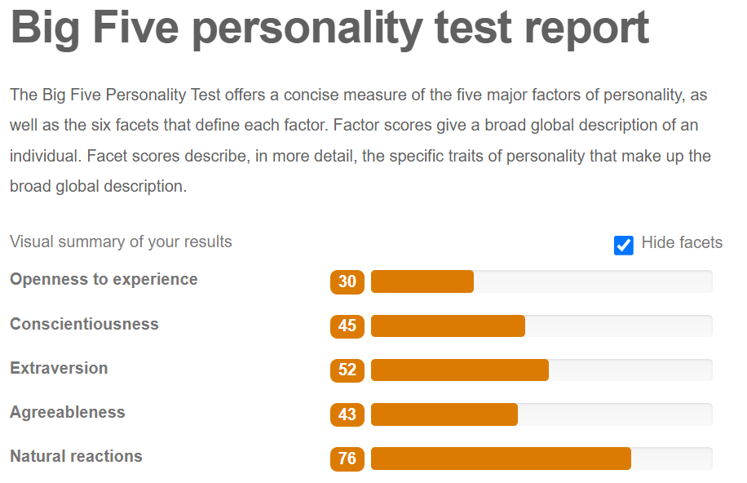

Openness to experience:

During the days of Procom’22 when I had to attend PR meetings since I was a team member, where it was all discussed about the event, I used to skip those using an excuse of ongoing classes. Maye because attending regular classes has made me conservative in a way that I no longer like sudden changes to my routine.

Conscientiousness:

Whenever I am attempting any exam, most of the time I am skimming the question and ignore those precise details that have been particularly mentioned to be noticed. In the previous semester, while attempting the final exam of Linear Algebra I did all the 10 questions where we had to do just 8 because I didn’t read and skip all those details.

Extraversion:

During psychology classes even though I want to anticipate in the conversation or give any opinion about whatever is being asked, because of being reserved, I choose to stay quiet.

Agreeableness:

Most of the time I am very sympathetic with people. I used to stay polite too. Since the percentile is in the middle, so it is very true that I rarely trust people. I listen to everything what people has to say but I don’t trust a thing unless I have thought about that a bit deeper.

Natural Reactions:

I often get frustrated too easily. Whenever I had to attend any lab in the morning, it makes me very stressed since I am very upset to see the condition of the lab (broken chairs that causes pain in the back, older display that causes eye strain too easily). The negative reaction to all this situation is I am unable to do any task that has been given.